Test 3

Note:
- Using ADO.NET
- Database: DBScript1.sql
Write a Windows Forms application to add new Material Type.
1. User Interface (4 point)
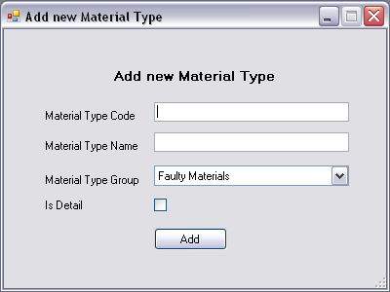
Requirements:
- Uses ComboBox control to display data of MaterialGroups table.
- Orders data by GroupName ascending.
2. Validation (1 point)
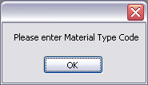 | 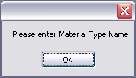
Requirements:
- Requires user to input value for Material Type Code and Material Type Name.
3. Event “Click” of “Add” button (4 point)
After validation,
- Adds a new Material Type into database. (3 point)
- Displays a new dialog box: (1 point)
